Sampling Strategy

1. Simple Random Sampling
2. Stratified Random Sampling
3. Clustering Sampling= naturally existing group (eg: gender, race); stratified sampling groups are decided by researchers (age groups decided by researcher etc)
4. Convenient Sampling

Population Sample

1. Num of Observations
2. Mean
3. Standard Deviation
4. Variance

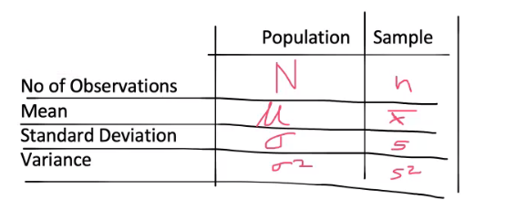

X Bar = x1 + x2 + x3 …. Xn

**Confidence Interval (CI):**

* You visit 5% of restaurants in Singapore
* You Conclude the average price of meal in Singapore is $30
* It may happen that the true average meal price $20--$40 : 90-95% of the time… 5%-10% chance is there it may be outside range
* We are confident that 95% of the parameter will remain in the range ($20 – $40)
* (5—10)% of restaurants lying outside $(20—40) range

Alpha (a): likelihood that the true population parameters lie outside the confidence interval

Alpha = 1-CI

Confidence Interval (CI) + Alpha = 1 or 100%

A 95% Confidence Interval means that you are sure that 95% of the case, the true population parameter would fall into the specific interval.

Practice Qn1

A manufacturer of light bulbs wants to make an estimate of the average life of the bulb within 10 hours. They want to be 99% confident of the prediction.

How many bulbs they need to test?

N = ? Margin of error = 10 hours

CI = 0.005

1 – 0.005 = 0.995

Z table score = 2.575

N = (2.575)^2 x 100

663

Practice Qn 2

The election campaign for a politician conducts a survey of 100 registered vote.

They find that 55 will vote for their candidate and 45 will vote for opponent

Approximately how confident can the campaign be that their candidate will win the election?

Sample size n = 100

P bar = 55%

Z score = (x – xbar) / std

= (55 – 50) (sqrt (0.5*0.5) /100 )

= 4.09

85% confident